## WEATHER IN APP

*A project report submitted in partial fulfillment of the requirements for the 6th semester of the degree of*

## BACHELOR OF VOCATION (B.Voc)

in

## WEB DEVELOPMENT

Submitted by

|  |  |
| --- | --- |
| **UNIVERSITY ROLL NO.** | **STUDENT NAME** |
| 20021251502 | ANJANI |
| 20021251504 | ANSHU KUMARI |

Under the Supervision of

## Ms. Poonam Chhabra



**Community College of Skill Development**

**J. C. Bose University of Science and Technology, YMCA Faridabad, Haryana - 12006**

**MAY, 2022**

 **DECLARATION**

We hereby declare that this submission is our own work and that, to the best of our knowledge and belief, it contains no material previously published or written by another person nor material which to a substantial extent has been accepted for the award of any other degree or diploma of the University or other institute of higher learning, except where due acknowledgment has been made in the text.

Signature:

Name and Roll No.

* Anjani 20021251502
* Anshu Kumari

20021251504

Date….

# ACKNOWLEDGEMENT

We make a move to communicate our profound feeling of appreciation and regard towards our supervisor Ms. Poonam Chhabra, Community College of Skill Development,

J. C. Bose University of Science and Technology YMCA Faridabad.

We are particularly obliged her for liberality, aptitude, and direction. Without her help and ideal direction, the fruition of this report would have appeared to be an outlandish dream. In this regard, we observe ourselves to be fortunate to have her as our guide. She has directed us with the topic as well as shown us the legitimate style and method of working and showing. It is an incredible joy for us to offer our thanks to the people who are associated with the fulfillment of our course report.

### Anjani -20021251502

### Anshu kumari - 20021251504

**CERTIFICATE**

This is to certify that the project entitled **“Weather in App”** submitted by **Anjani and Anshu kumari** in the fulfillment of the requirement for the award of the degree of Bachelor of Vocation in Web Development under Community College of Skill Development, **“J.C. Bose University of Science and Technology YMCA Faridabad”,** during the academic year 2019-2022, is a bonafide record of work carried out under my guidance and supervision. I further declare that to the best of my knowledge, the project does not contain any part of any work which has been submitted for the award of any degree either in this university or in any other university.

### Ms. Poonam Chhabra

(Supervisor)

**Dr. Sanjeev Goyal**

(Principal)

Community College of Skill Development

JC Bose University of Science & Technology

YMCA Faridabad

**Project Report**

**On**

**“Weather Web Application”**

**TABLE OF CONTENTS**

|  |  |
| --- | --- |
| **CHAPTERS** | **PAGE NO** |
| DECLARATION  ACKNOWLEDGEMENT  CERTIFICATE  ABSTRACT |
| CHAPTER 1: INTRODUCTION |
| * 1. INTRODUCTION |
| * 1. PROBLEM DEFINITION |
| * 1. SCOPE |
| * 1. PURPOSE |
| 1.5 PROBLEM AND EXISTING TECHNOLOGY |
| 1.6 PROPOSED SYSTEM |
|  |
| CHAPTER 2: REQIUREMENTS & ANALYSIS |
| 2.1 PLATFORM REQUIREMENTS |
| 2.2 MODULE DESCRIPTION |
|  |
| CHAPTER 3: DESIGN & IMPLEMENTATION |
|  |
| 3.1 ALGORITHMS |
| 3.2 PSEUDO CODE |
| CHAPTER 4: SCREENSHOTS |
|  |
| CHAPTER 5: CONCLUSION |
|  |
| CHAPTER 6: REFERENCES |  |

**ABSTRACT**

Weather forecasting is the application of science and technology to predict the state of the atmosphere for a given location. Ancient weather forecasting methods usually relied on observed patterns of events, also termed pattern recognition. For example, it might be observed that if the sunset was particularly red, the following day often brought fair weather. However, not all of these predictions prove reliable.

Here this system will predict weather based on parameters such as temperature, humidity and wind. User will enter current temperature; humidity and wind, System will take this parameter and will predict weather (rainfall in inches) from previous data in database(dataset). The role of the admin is to add previous weather data in database, so that system will calculate weather (estimated rainfall in inches) based on these data. Weather forecasting system takes parameters such as temperature, humidity, and wind and will forecast weather based on previous record therefore this prediction will prove reliable. This system can be used in Air Traffic, Marine, Agriculture, Forestry, Military, and Navy etc.

**1.INTRODUCTION**

* **Data Warehousing**

Data Warehouse is electronic storage of a large amount of information by a business which is designed for query and analysis instead of transaction processing. It is a process of transforming data into information and making it available to users for analysis.

* **Data Mining**

Data mining is looking for hidden, valid, and potentially useful patterns in huge data sets. Data Mining is all about discovering unsuspected/ previously unknown relationships amongst the data. It is a multi-disciplinary skill that uses machine learning, statistics, AI and database technology.

**1.1. Introduction**

Rainfall Prediction is the application of science and technology to predict the amount of rainfall over a region. It is important to exactly determine the rainfall for effective use of water resources, crop productivity and pre-planning of water structures.

In this project, we used Linear Regression to predict the amount of rainfall. Linear Regression tells us how many inches of rainfall we can expect.

**1.2 Problem Definition**

It is important to exactly determine the rainfall for effective use of water resources, crop productivity and pre-planning of water structures.

**1.3 Scope**

It tells us how many inches of rainfall we can expect.

**1.4 Purpose**

There are several reasons why weather forecasts are important. They would certainly be missed if they were not there. It is a product of science that impacts the lives of many people. The following is a list of various reasons why weather forecasts are important:  
1. Helps people prepare for how to dress (i.e. warm weather, cold weather, windy weather, rainy weather)  
2. Helps businesses and people plan for power production and how much power to use (i.e. power companies, where to set thermostat)  
3. Helps people prepare if they need to take extra gear to prepare for the weather (i.e. umbrella, rain coat, sun screen)  
4. Helps people plan outdoor activities (i.e. to see if rain/storms/cold weather will impact outdoor event)  
5. Helps curious people to know what sort of weather can be expected (i.e. a snow on the way, severe storms)  
6. Helps businesses plan for transportation hazards that can result from the weather (i.e. fog, snow, ice, storms, clouds as it relates to driving and flying for example)  
7. Helps people with health related issues to plan the day (i.e. allergies, asthma, heat stress)  
8. Helps businesses and people plan for severe weather and other weather hazards (lightning, hail, tornadoes, hurricanes, ice storms)  
9. Helps farmers and gardeners plan for crop irrigation and protection (irrigation scheduling, freeze protection)

**1.5 Problem and Existing Technology**

The traditional forecast process employed by most NMHSs involves forecasters producing text-based, sensible, weather-element forecast products (e.g. maximum/minimum temperature, cloud cover) using numerical weather prediction (NWP) output as guidance. The process is typically schedule-driven, product-oriented and labour-intensive. Over the last decade, technological advances and scientific breakthroughs have allowed NMHSs’ hydro meteorological forecasts and warnings to become much more specific and accurate.

As computer technology and high-speed dissemination systems evolved (e.g. Internet), National Weather Service (NWS) customers/partners were demanding detailed forecasts in gridded, digital and graphic formats. Traditional NWS text forecast products limit the amount of additional information that can be conveyed to the user community. The concept of digital database forecasting provides the capability to meet customer/partner demands for more accurate, detailed hydro meteorological fore­casts. Digital database forecasting also offers one of the most exciting opportunities to integrate PWS forecast dissemination and service delivery, which most effectively serves the user community.

**1.6 Proposed System**

User will enter current temperature; humidity and wind, System will take this parameter and will predict weather from previous data in database. The role of the admin is to add previous weather data in database, so that system will calculate weather based on these data.

**2.REQUIREMENTS**

**2.1. Platform Requirements**

|  |  |  |
| --- | --- | --- |
| Hardware/Software | Hardware / Software element | Specification /version |
| Hardware | Processor | i3 |
| RAM | 3GB |
| Hard Disk  Screen resolution  Internet connection | 250GB  1280x1024 or larger  Required |
| Software | OS | Windows, Linux.  Visual Studio Code.  Internet Explorer  Adobe Photoshop |
| HTML editor  Web browsers  Graphics editor |

**2.2. Modules Description**

**In this project we have Two modules**

1. Data gathering and pre - processing.
2. Applying Algorithm for live update.

**Explanation:**

1. In this module we first gather the data(dataset) for our live model. Data comes in all forms, most of it being very messy and unstructured. They rarely come ready to use. Datasets, large and small, come with a variety of issues- invalid fields, missing and additional values, and values that are in forms different from the one we require. In order to bring it to workable or structured form, we need to “clean” our data, and make it ready to use. Some common cleaning includes parsing, converting to one-hot, removing unnecessary data, etc.

In our case, our data has some days where some factors weren’t recorded. And the rainfall in cm was marked as T if there was trace precipitation. Our algorithm requires numbers, so we can’t work with alphabets popping up in our data. so we need to clean the data before applying it on our model.

2)Once the data is cleaned, In this module that cleaned data can be used as an input to our Linear regression model. Linear regression is a linear approach to form a relationship between a dependent variable and many independent explanatory variables. This is done by plotting a line that fits our scatter plot the best, ie, with the least errors. This gives value predictions, i.e., how much, by substituting the independent values in the line equation.

We will use Scikit-learn’s linear regression model to train our dataset. Once the model is trained, we can give our own inputs for the various columns such as temperature, dew point, pressure, etc. to predict the weather based on these attributes.

**Module Outcomes:**

1. By the end of the first module the fully cleaned and useful data is available for the apply the algorithm for the LIVE.
2. By the end of the second module the actual live update will be happen the outcome is the amount of rainfall in inches based upon the users input.

**Algorithm:**

**Linear Regression** is a machine learning algorithm based on **supervised learning**. It performs a **regression task**. Regression models a target prediction value based on independent variables. It is mostly used for finding out the relationship between variables and forecasting. Different regression models differ based on – the kind of relationship between dependent and independent variables, they are considering and the number of independent variables being used.

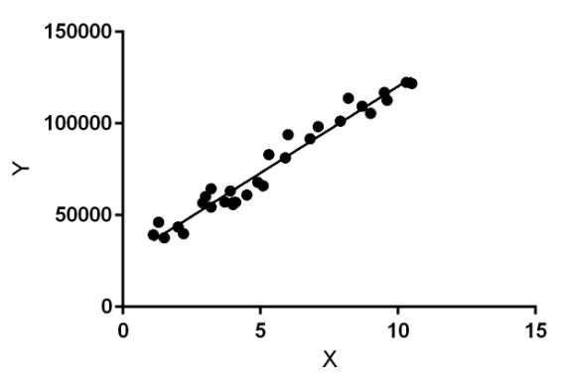

Linear regression performs the task to predict a dependent variable value (y) based on a given independent variable (x). So, this regression technique finds out a linear relationship between x (input) and y(output). Hence, the name is Linear Regression.  
In the figure above, X (input) is the work experience and Y (output) is the salary of a person. The regression line is the best fit line for our model.

**Hypothesis function for Linear Regression :**  
y=mx+c

Where

**y** is the response variable.

**x** is the predictor variable.

**m** and **c** are constants which are called the coefficients.

**2.3. Data Set**

The dataset is a public weather dataset from Austin, Texas available on Kaggle.

austin_weather.csv

**Columns:**

Date-

The date of the collection (YYYY-MM-DD)

Temp High F-

High temperature, in degrees Fahrenheit

Temp Avg F-

Average temperature, in degrees Fahrenheit

Temp Low F-

Low temperature, in degrees Fahrenheit

Dew Point High F-

High dew point, in degrees Fahrenheit

Dew Point Avg F-

Average dew point, in degrees Fahrenheit

Dew Point Low F-

Low dew point, in degrees Fahrenheit

HumidityHighPercent-

High humidity, as a percentage

HumidityAvgPercent-

Average humidity, as a percentage

HumidityLowPercent-

Low humidity, as a percentage

SeaLevelPressureHighInches-

High sea level pressure, in inches of mercury

SeaLevelPressureAvgInches-

Average sea level pressure, in inches of mercury

SeaLevelPressureLowInches-

Low sea level pressure, in inches of mercury

VisibilityHighMiles-

High visibility, in miles

VisibilityAvgMiles-

Average visibility, in miles

VisibilityLowMiles-

Low visibility, in miles

WindHighMPH-

High wind speed, in miles per hour

WindAvgMPH-

Average wind speed, in miles per hour

WindGustMPH-

Highest wind speed gust, in miles per hour

PrecipitationSumInches-

Total precipitation, in inches ('T' if trace)

Events-

Adverse weather events (' ' if None)

**3.DESIGN AND IMPLEMENTATION**

**3.1 Algorithms:**

Linear Regression:

**Module-1: Data** gathering and pre - processing.

**Module-2:** Applying Algorithm for live update.

**3.2Source Code**

<!

DOCTYPE html>

<html lang="en">

  <head>

    <!---------------meta tag for responsive------------------>

    <meta charset="UTF-8" />

    <meta name="viewport" content="width=device-width, initial-scale=1.0" />

    <title>Weather in App</title>

    <!-----------------bootstrap 5 file link------------------>

    <link rel="stylesheet" href="css/bootstrap.min.css">

    <!---------------------external css link----------------->

    <link rel="stylesheet" href="css/index.css" />

    <!--------------------font awesome icon cdn link-------------->

    <link rel="stylesheet" href="https://cdnjs.cloudflare.com/ajax/libs/font-awesome/5.10.1/css/all.min.css" integrity="sha512-9my9Mb2+0YO+I4PUCSwUYO7sEK21Y0STBAiFEYoWtd2VzLEZZ4QARDrZ30hdM1GlioHJ8o8cWQiy8IAb1hy/Hg==" crossorigin="anonymous" referrerpolicy="no-referrer" />

  </head>

<body>

  <!---------------------background video link---------------->

  <video id="background-video" autoplay loop muted pause="img/bg.mp4" >

    <source src="img/bg.mp4" type="video/mp4">

  </video>

  <!-------------------------navbar section----------------------------->

    <nav class="navbar navbar-expand-lg bg-none navbar-light p-1">

<div class="container">

        <a class="navbar-brand" href="index.html">

          <img src="img/lOGO.png" alt="logo" class="img-fluid"><span>Weather-in</span>

        </a>

        <button class="navbar-toggler" type="button" data-bs-toggle="collapse" data-bs-target="#collapsibleNavbar2">

          <span class="navbar-toggler-icon"></span>

        </button>

        <div class="collapse navbar-collapse justify-content-end" id="collapsibleNavbar2">

          <ul class="navbar-nav text-capitalize">

            <li class="nav-item"><a class="nav-link active" href="index.html">Home</a></li>

            <li class="nav-item"><a class="nav-link" href="about.html">About us</a></li>

            <li class="nav-item"><a class="nav-link" href="news.html">news</a></li>

            <li class="nav-item"><a class="nav-link" href="search.html"><i class="fas fa-search mx-2"></i></a></li>

          </ul>

        </div>

      </div>

    </nav>

  <!----------------------------content section------------------------>

    <div class="content">

      <div class="container">

        <h2>wanna go out, let's check the weather to make your trip amazing and memorable</h2>

        <div class="button col-md-4 col-lg-2 col-sm-6 mx-auto d-flex mt-4">

          <a class="btn btn-outline-dark" href="search.html" role="button">Check Weather<i class="fas fa-search mx-2"></i> </a>

        </div>

      </div>

    </div>

  <!------------------------script files------------------->

  <script src="js/index.js"></script>

  <script src="js/request.js"></script>

  <script src="js/bootstrap.min.js"></script>

<body>

</html>

Stylesheet code:

@import url('https://fonts.googleapis.com/css2?family=Raleway:wght@100;400;700&display=swap');

body {

  font-family: 'Raleway', sans-serif;

  background-image: url(https://i.pinimg.com/originals/07/51/c8/0751c8740aeb0c0bd78d62ca265b8746.jpg);

  background-repeat: no-repeat;

  background-size: cover;

  color: #707070;

  margin: 0;

  padding: 0;

}

.navbar-brand span{

  color: #fff;

  font-weight: 700;

  padding: 5px 3px;

}

.title{

  font-size: 65px !important;

  color: #fff;

  padding: 30px 0px 20px 0px;

}

.container {

  max-width: 400px;

  min-width: 400px;

}

.title {

  font-weight: 700;

  font-size: 50px;

}

.form-rounded {

  border-radius: 2em;

}

.search-loaction{

  margin-bottom: 50px;

}

.

back-card {

  border-radius: 30px !important;

}

.back-card:hover{

  box-shadow: 1px 1px 20px rgb(215, 219, 220) !important;

  transition-duration: 1.5s;

}

.city-name {

  position: absolute;

  width: 100%;

}

.city-name p {

  font-size: 16pt;

  font-weight: 400;

}

.city-name span {

  font-weight: 400;

  font-size: 36pt;

  font-family: 'Times New Roman', Times, serif;

  position: relative;

  top: -60px;

}

.temp span {

  font-weight: 100;

  font-size: 5em;

  letter-spacing: -5px;

  white-space: nowrap;

}

.card-mid {

  line-height: 0.5;

}

.condition {

  line-height: 1em;

  font-weight: 700;

  font-size: 1em;

  text-transform: capitalize;

}

.

high::before {

  content: '';

  background: url('img/up.svg') no-repeat;

  width: 10px;

  height: 15px;

  display: inline-block;

  position: relative;

  top: 3px;

}

.low::before {

  content: '';

  background: url('img/down.svg') no-repeat;

  width: 10px;

  height: 15px;

  display: inline-block;

  position: relative;

  top: 3px;

}

.icon-container {

  border-radius: 100%;

  width: 100px;

  height: 100px;

  background: #94c9ff;

}

.icon-container img {

  margin: auto;

}

.card-bottom {

  line-height: 0.5;

}

.card-bottom span {

  font-size: 12px;

}

.card-bottom p {

  font-size: 50px;

  font-weight: 100;

  letter-spacing: -2px;

}

@media screen and (min-device-width: 310px) and (max-device-width: 1024px) {

  body{

    background-size: auto;

  }

}

JavaScript code:

const key = 'cbe3dd267a18f6c89943b3eff94f1ed7';

// const baseURL = 'http://api.lopenweathermap.org/data/2.5/weather?q=Lagos&appid=cbe3dd267a18f6c89943b3eff94f1ed7';

// fetch(baseURL)

//     .then((data) => { console.log('response', data.json()) })

//     .catch((error) => {

//         console.log(error);

//     });

const requestCity = async (city) => {

    const baseURL = 'http://api.openweathermap.org/data/2.5/weather'

    const query = `?q=${city}&appid=${key}`;

    //make fetch call (promise call)

    const response = await fetch(baseURL + query);

    //promise data

    const data = await response.json();

    return data;

}

const searchForm = document.querySelector('.search-loaction');

const cityValue = document.querySelector('.search-loaction input');

const cityName = document.querySelector('.city-name p');

const cardBody = document.querySelector('.card-body');

const timeImage = document.querySelector('.card-top img');

const cardInfo = document.querySelector('.back-card');

const spitOutCelcius = (kelvin) => {

    celcius = Math.round(kelvin - 273.15);

    return celcius;

}

const isDayTime = (icon) => {

    if (icon.includes('d')) { return true }

    else { return false }

}

updateWeatherApp = (city) => {

    console.log(city);

    const imageName = city.weather[0].icon;

    const iconSrc = `http://openweathermap.org/img/wn/${imageName}@2x.png`

    cityName.textContent = city.name;

    cardBody.innerHTML = `

    <div class="card-mid row">

            <div class="col-8 text-center temp">

              <span>${spitOutCelcius(city.main.temp)}&deg;C</span>

            </div>

            <div class="col-4 condition-temp">

              <p class="condition">${city.weather[0].description}</p>

              <p class="high">${spitOutCelcius(city.main.temp_max)}&deg;C</p>

              <p class="low">${spitOutCelcius(city.main.temp_min)}&deg;C</p>

            </div>

          </div>

          <div class="icon-container card shadow mx-auto">

            <img src="${iconSrc}" alt="" />

          </div>

          <div class="card-bottom px-5 py-4 row">

            <div class="col text-center">

              <p>${spitOutCelcius(city.main.feels_like)}&deg;C</p>

              <span>Feels Like</span>

            </div>

            <div class="col text-center">

              <p>${city.main.humidity}%</p>

              <span>Humidity</span>

            </div>

          </div>

    `;

    if (isDayTime(imageName)) {

        console.log('day');

        timeImage.setAttribute('src', 'img/day_image.svg');

        if (cityName.classList.contains('text-white')) {

        cityName.classList.remove('text-white');

        } else {

            cityName.classList.add('text-black');

        }

    } else {

        console.log('night');

        timeImage.setAttribute('src', 'img/night_image.svg');

        if (cityName.classList.contains('text-black')) {

            cityName.classList.remove('text-black');

        } else {

            cityName.classList.add('text-white');

        }

    }

    cardInfo.classList.remove('d-none');

}

//add an event listner to the form

searchForm.addEventListener('submit', e => {

    e.preventDefault();

    const citySearched = cityValue.value.trim();

    console.log(citySearched);

    searchForm.reset();

    requestCity(citySearched)

        .then((data) => {

            updateWeatherApp(data);

        })

        .catch((error) => { console.log(error) })

 })

**4. SCREENSHOTS**

**Landing Page**

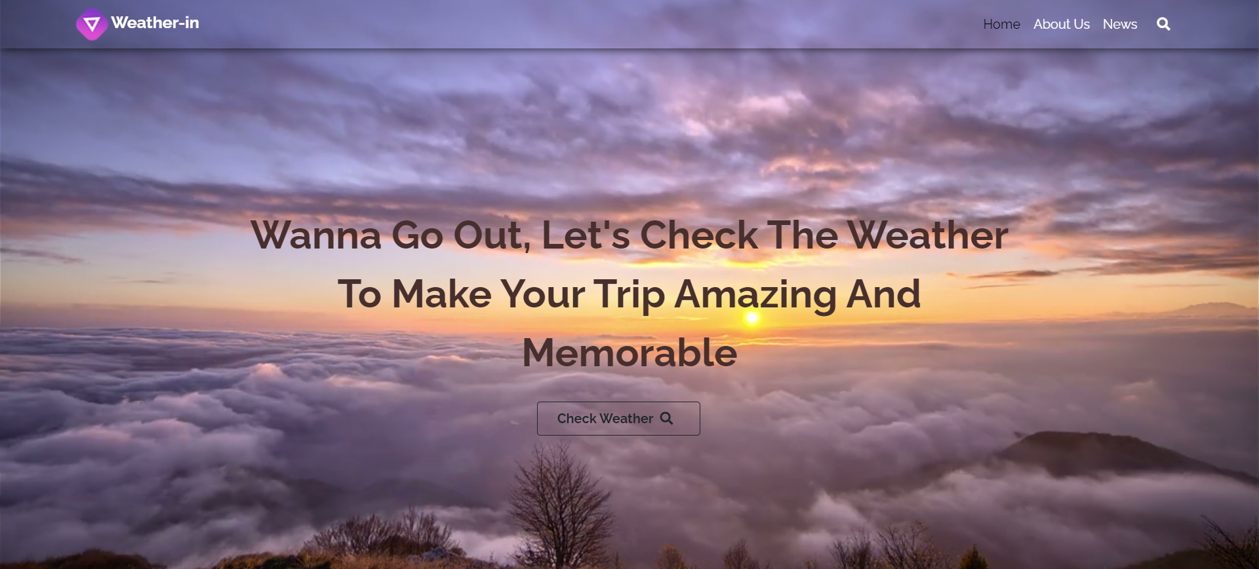

**About US Page**

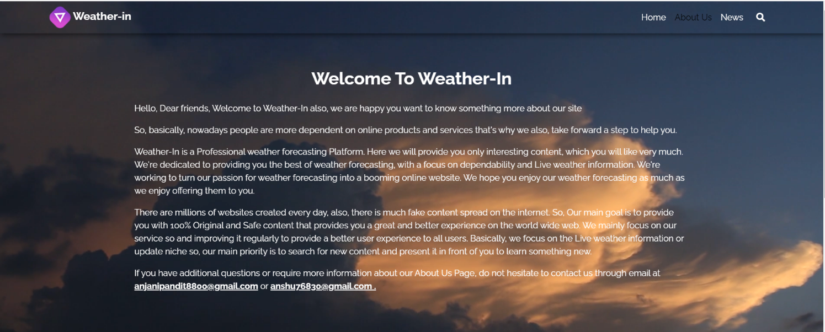

**Our Team Page:**

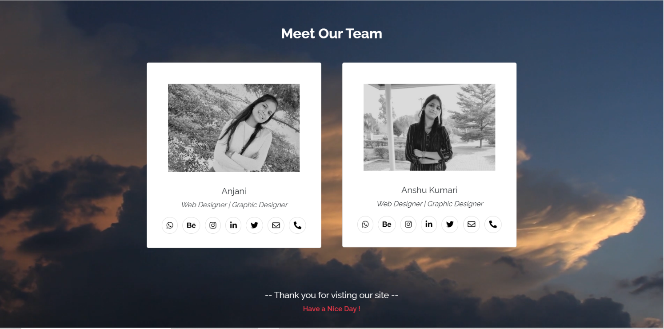

**Check Weather Page:**

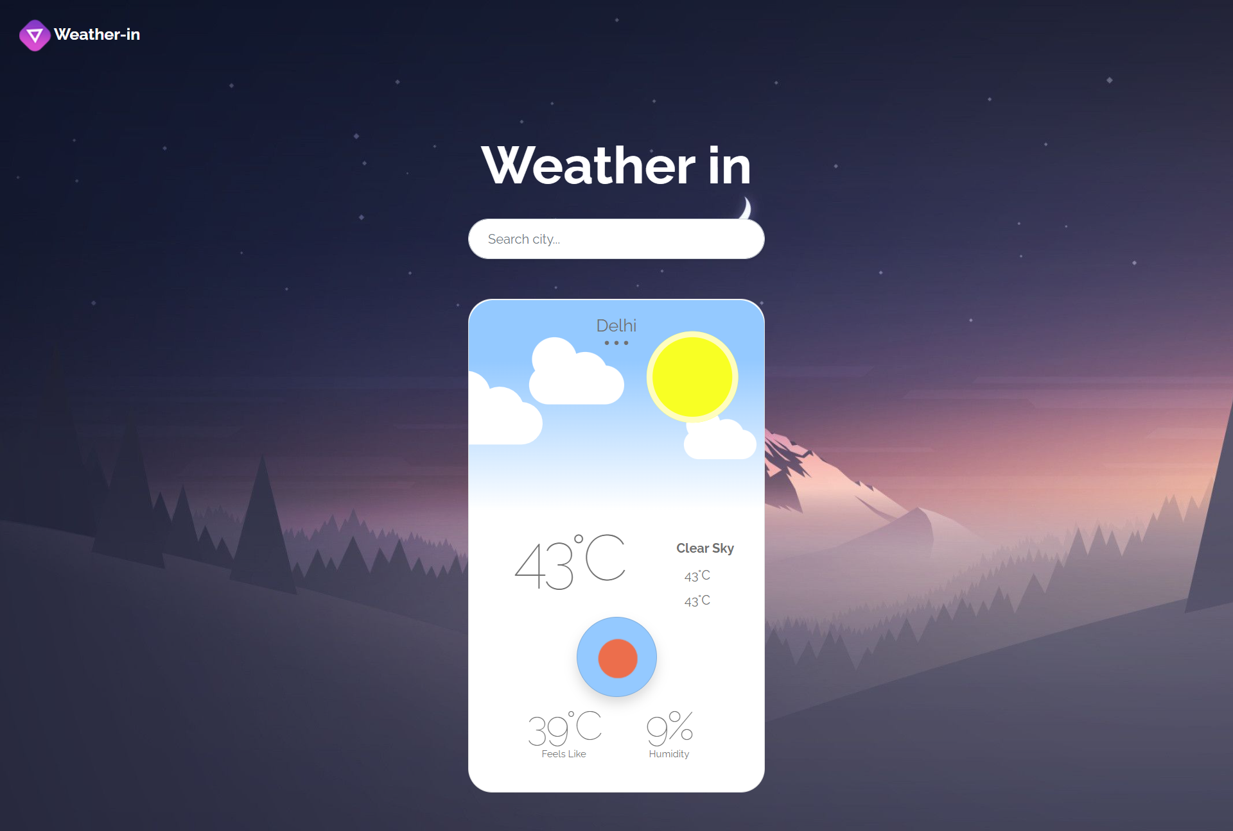

**News Page:**

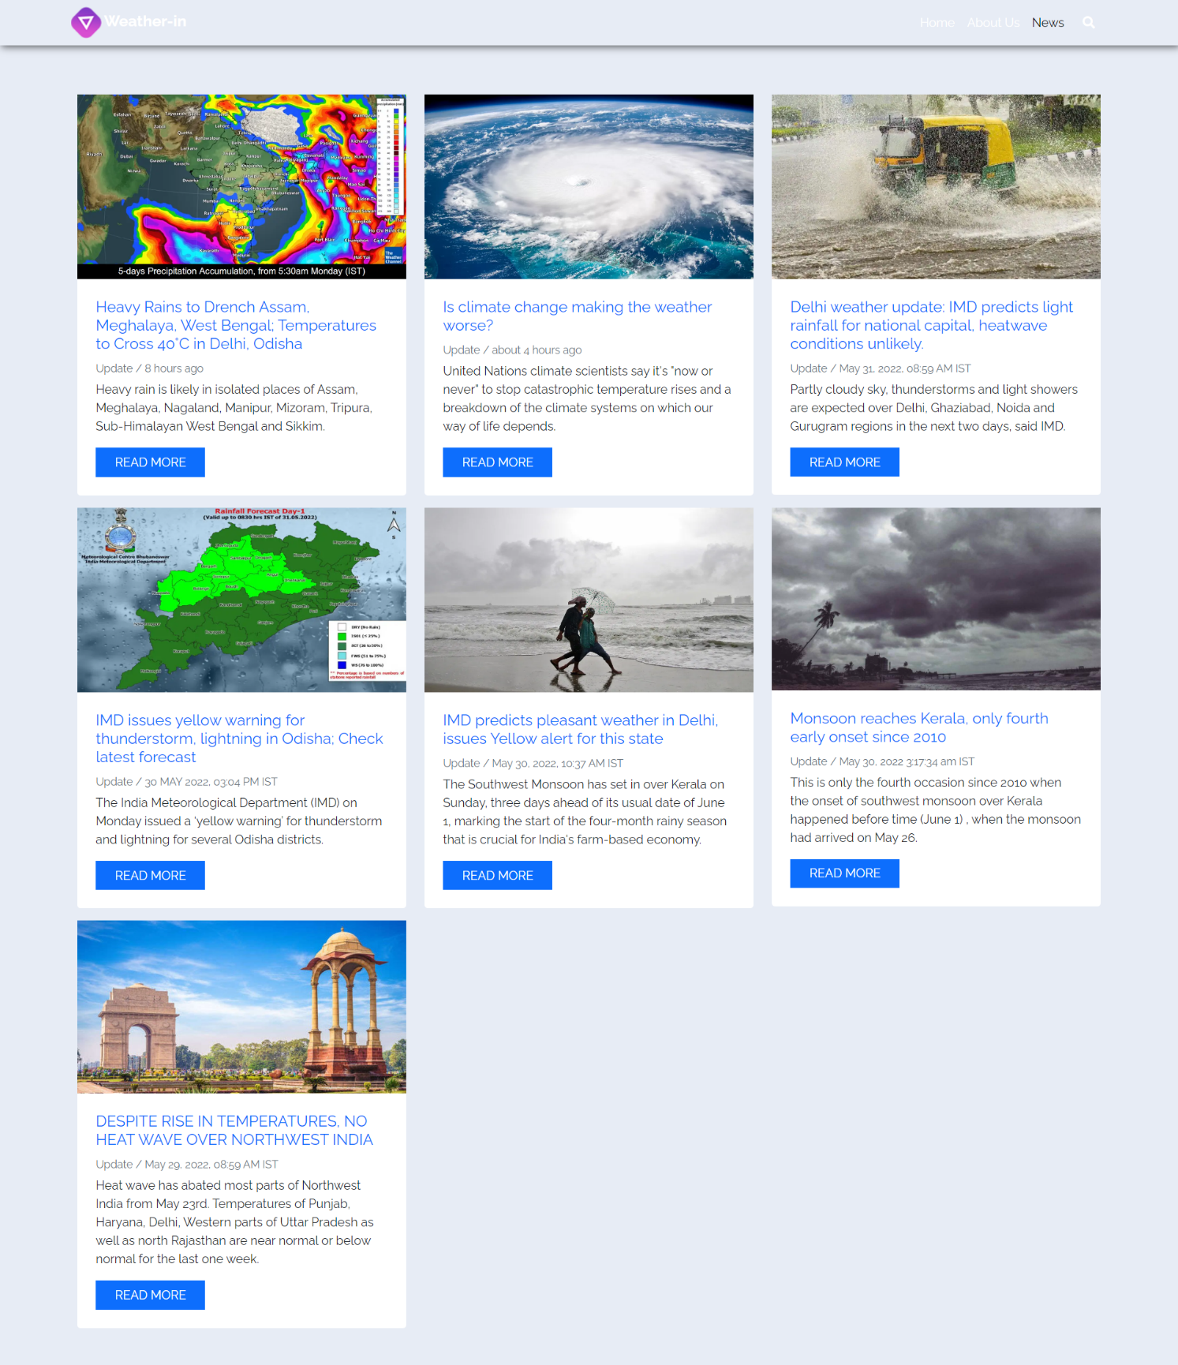

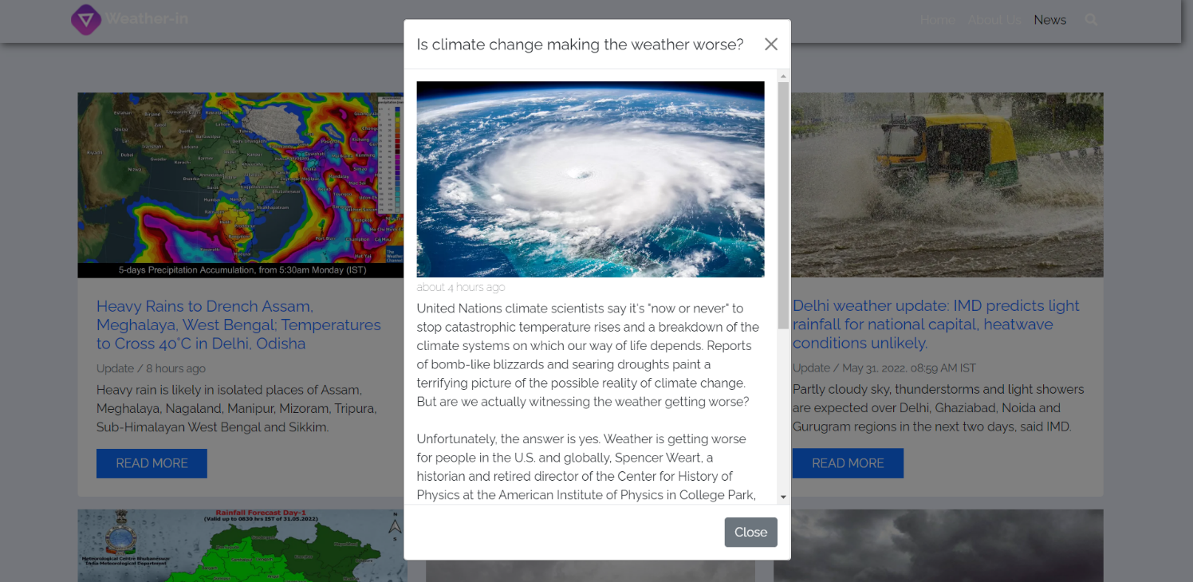

**5.CONCLUSION**

We successfully provide the live weather update by using Weather API but here it will not able to predicate the weather forecast for the future requirement and this will not tell the user about the rainfall.

**6.REFERENCES**

# Textbooks: -

# Data Mining: The Textbook 2015 Edition, Kindle Edition by [Charu C. Aggarwal](https://www.amazon.in/Charu-C-Aggarwal/e/B00E6PGCPM/ref=dp_byline_cont_ebooks_1) .

# Data Mining: Concepts and Techniques By Jiawei Han, Jian Pei, Micheline Kamber.